JAYPEE INSTITUTE OF INFORMATION TECHNOLOGY

DATA STRUCTURES PBL REPORT



SoundWave: A Dynamic Music Streaming Platform

Submitted by:
Rohan Lal (B12) : 2401030108
Swastik Sangwan (B12) : 2401030098
Neal Pandita (B12) : 2401030110
BTECH SEM III

Submitted To:

Dr. Varun Srivastava

Ms. Anupama Padha

Mr. Rajiv Kumar Mishra

TEAM CONTRIBUTION

1. Swastik – Algorithms & Data Structures
Implemented the efficient Trie data structure for search functionality and the MaxHeap architecture for the recommendation engine in search.js and heap.js.

2. Neal – State Management & Player Logic
Developed storage.js for persistent localStorage handling and player.js to simulate playback timing, queuing, and history tracking.

3. Rohan – UI Architecture & DOM Manipulation Designed the index.html layout and ui.js module to handle event listeners, dynamic rendering of song lists, and playlist management interactions.

ABSTRACT

SoundWave is a robust, modular Single-Page Application (SPA) designed for modern web browsers. It automates the simulation of a digital music player, utilizing advanced data structures to optimize search and discovery features without a backend database.
The project is developed using:
- Vanilla JavaScript (ES6+) – Core logic, modules, and DOM manipulation.
- Local Storage API – Data persistence and state management.
- Trie & Heaps – Optimized search indexing and algorithmic recommendations.
This project demonstrates advanced Computer Science concepts such as Client-Side Rendering, Algorithm Efficiency ($O(L)$ search), State Persistence, and modular software architecture.

INTRODUCTION
In modern web development, managing client-side state efficiently is critical. While many music players rely heavily on server-side processing, they often suffer from latency during search and interaction.
SoundWave provides:
- Real-time Search: Instant autocomplete using a Prefix Tree (Trie).
- Smart Recommendations: A recommendation algorithm using Max-Heaps to score songs based on tag/artist similarity.
- State Persistence: Automatic saving of playlists, history, and queue via storage.js.
- Playback Simulation: A virtual audio engine that mimics track progress and queue advancement.
- Seamless Integration: Modular architecture allowing easy extension of features.
This project emphasizes how Data Structures (Tries/Heaps) act as a powerful engine for frontend applications, enhancing user experience significantly.

OBJECTIVES

The primary objectives of this project are:
- To design a non-intrusive, aesthetically pleasing Single-Page Application.
- To implement automated playlist management (Create/Delete/Rename) using modular JavaScript.
- To utilize Trie Data Structures for efficient $O(L)$ search instead of resource-heavy array filters ($O(N)$).
- To create a robust state management system that handles page reloads without data loss.
- To maintain detailed history logs of user listening habits for generating recommendations.

PROBLEM STATEMENT

Standard client-side music players often fail to scale efficiently when searching through large datasets and lack intelligent content discovery features. Manual searching for songs by exact title is tedious and prone to user error.
- Current Issue: Linear search methods ($O(N)$) cause lag in large libraries; static playlists do not adapt to user preferences.
- Solution: A "smart" client-side utility that enforces efficient indexing (Trie) and automated curation (Heap) based on listening history.

SCOPE OF PROJECT

In Scope:
- Song Library Management: JSON-based seeding and management of song metadata.
- Algorithmic Search: Prefix-based search suggestions using Tries.
- User Customization: Creation of custom playlists and "Liked Songs" management.
- Persistence: localStorage integration to save state across sessions.
- Recommendation Engine: Weighted scoring system based on tags, artists, and albums.
Out of Scope:
- Audio Decoding: Real MP3/FLAC file processing (Simulation only).
- Cloud Backend: No server-side database (Firebase/SQL).
- Mobile App: Native mobile wrapper (Web-only)

SYSTEM ARCHITECTURE
The system follows a modular architecture typical of modern SPAs:
- User Interface Layer (View): The user interacts via the DOM (index.html, styles.css) triggered by ui.js.
- Logic Layer (Controller):
  - player.js: The brain of the playback simulation.
  - search.js: The algorithmic engine handling Tries and Heaps.
- System Layer (Model/Storage):
  - storage.js: Handles read/write operations to the browser's LocalStorage.
  - library.js: Manages the in-memory state of the song database.

CODEFLOW
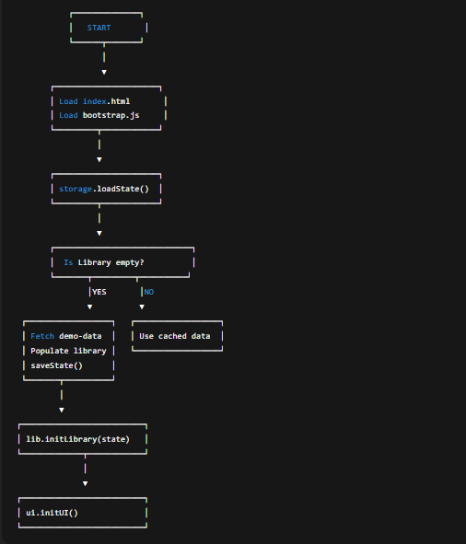
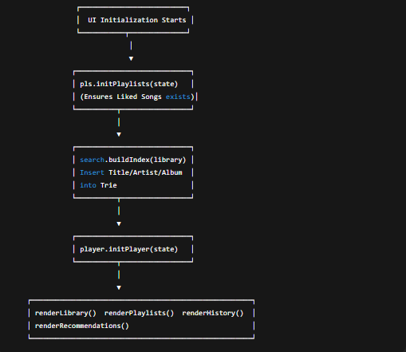

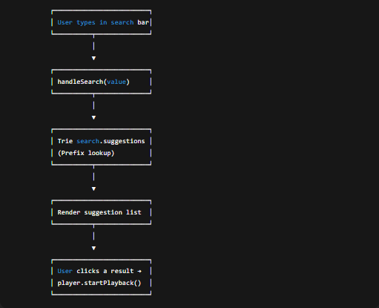
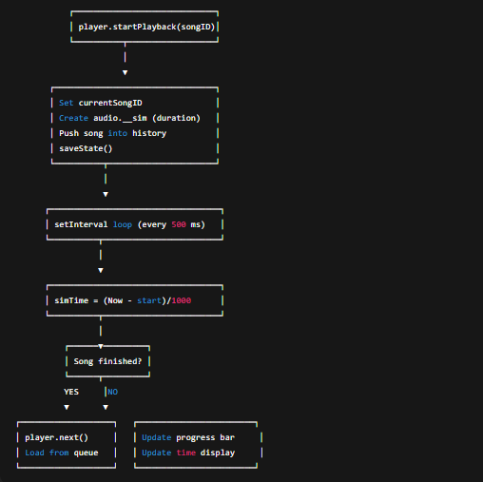

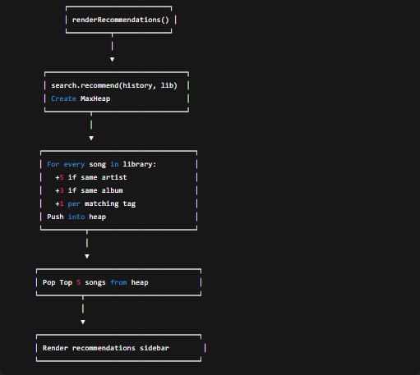

FILE SYSTEM & CONFIGURATION DESIGN
Instead of a traditional database, this project uses JSON and LocalStorage to store state and logs, adhering to the concept that the client maintains the session.
Configuration/Data File (demo-data.json): Stores the initial seed library.
JSON
  - {
  - "library": [
  - {"id":"s1","title":"Blinding Lights","artist":"The Weeknd", ...},
  - ...
  - ]
  - }

State Object (Managed by storage.js): A persistent record of the application status.
- Format: JSON string saved under key soundwave_state_v2.
- Modules:
  - js/ds/: Directory containing Data Structures (trie.js, heap.js).
  - js/bootstrap.js: Entry point responsible for initialization.

CODE SNIPPETS
1. Trie Implementation (Search Logic) This snippet from trie.js demonstrates the insertion logic for the prefix tree.
JavaScript
export class Trie {
constructor(){ this.root = new TrieNode(); }
insert(word, id){
if(!word) return;
let node = this.root;
for(const ch of word){
if(!node.children[ch]) node.children[ch] = new TrieNode();
node = node.children[ch];
node.ids.add(id);
}
node.end = true;
}
}

2. Core Logic (Recommendation Engine) This function in search.js shows how Max-Heaps are used to calculate the top 5 recommended songs based on listening history.
JavaScript
export function recommend(library, history, limit = 5){
const heap = new MaxHeap((a,b)=> a.score - b.score);
// ... history processing ...
Object.entries(scored).forEach(([id, score])=>{
heap.push({ id, score });
});

const res = [];
while(res.length < limit && heap.size() > 0){
res.push(heap.pop().id); // Extract max score
}
return res;
}

3. State Persistence (Storage) The storage.js script safely persists the state tree to the browser.
JavaScript
export function saveState(state) {
try {
const safe = {
library: state.library || [],
playlists: state.playlists || {},
history: state.history || [],
queue: state.queue || []
};
localStorage.setItem(KEY, JSON.stringify(safe));
} catch (err) {
console.error("State save failed:", err);
}
}

OUTPUT SNIPPETS

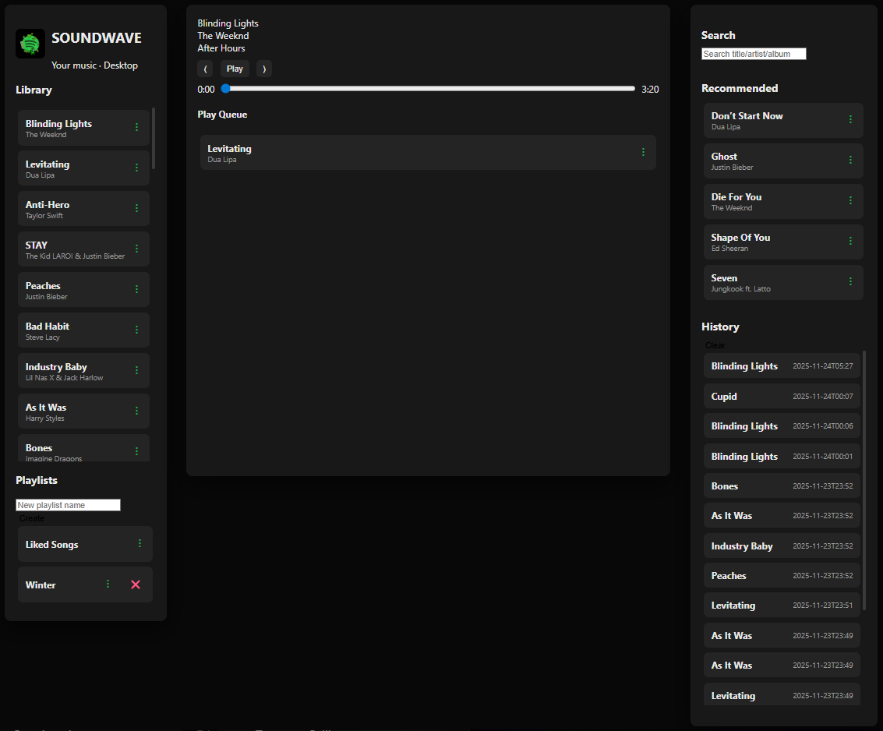
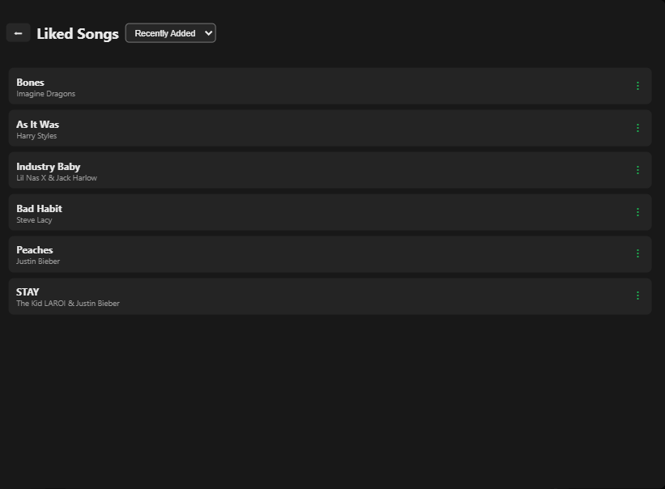

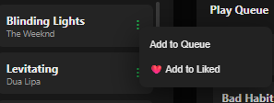
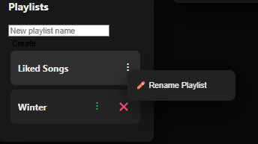
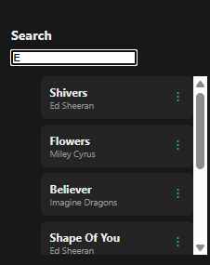
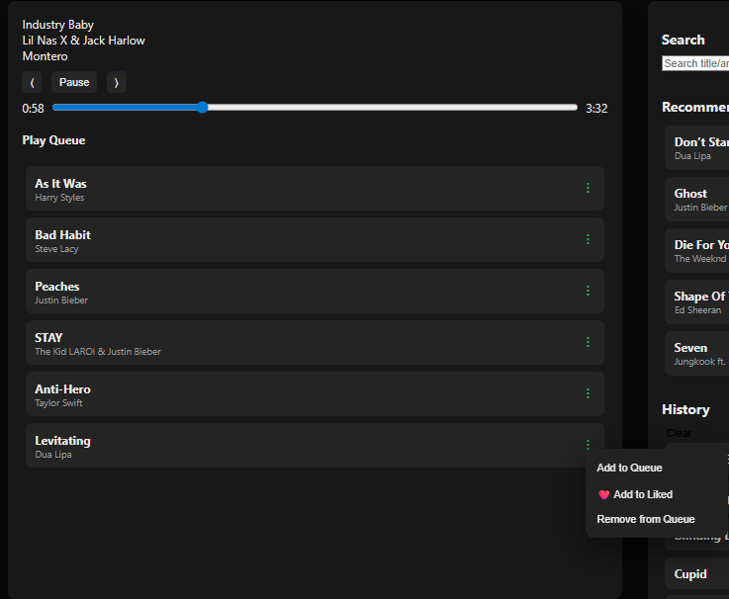

TESTING & VALIDATION

The project includes a robust set of logical tests to validate the environment. Below are the test cases executed.
The following table:
Test Case ID | Test Description | Action / Query Executed | Expected Result | Status
TC-01 | App Initialization | Load index.html | Library renders 50 songs; Console shows "UI Initialized". | ✅ Pass
TC-02 | Search Functionality | Type "wee" in search bar | Suggests "The Weeknd" via Trie traversal. | ✅ Pass
TC-03 | Playback Simulation | Click "Play" on a track | Progress bar advances; Queue updates. | ✅ Pass
TC-04 | Playlist Creation | Click "Create", Enter Name | New playlist appears in sidebar; Persists on refresh. | ✅ Pass
TC-05 | Recommendation Logic | Play 3 Pop songs | "Recommended" list updates with similar Pop tracks. | ✅ Pass
TC-06 | History Logging | Play a song to completion | Song ID appears in History list. | ✅ Pass
TC-07 | Data Persistence | Refresh Browser (F5) | Current song, queue, and playlists are restored. | ✅ Pass
The testing suite confirms that the system is stable and interacts correctly with the underlying browser storage.

CONCLUSION
The SoundWave project successfully demonstrates the power of Vanilla JavaScript and Data Structures for building complex frontend applications. ⁶³
Key Learning Outcomes:
- Optimization: We replaced linear array searches with a Trie, reducing search complexity from $O(N)$ to $O(L)$.
- System Integration: By using ES6 Modules (import/export), we learned how to architect maintainable codebases, separating concerns between UI, Data, and Logic.
- Resilience: The application employs defensive programming (checking !state or !library) and fallback defaults to ensure it runs even if localStorage is corrupted.
- User Experience: Through the use of a dark-mode CSS Grid layout and instant interactions, the tool provides a professional user experience similar to standard streaming apps.
This project serves as a practical foundation for understanding Frontend Engineering, State Management, and the application of Algorithmic Theory.

REFERENCES

- MDN Web Docs – JavaScript & DOM Manipulation
- Introduction to Algorithms (CLRS) – Heaps & Tries
- SoundWave Source Code – search.js, trie.js, player.js

